Chapter 5

The Use of Paleomagnetic Declinations

for Mesoamerica and China to Decode Orientation of Mesoamerican and Chinese Pyramids

Jaroslav Klokočník∗¹ and Jan Kostelecký²#
¹Astronomical Institute, p.r.i., Academy of Sciences of the Czech Republic,
CZ Ondřejov Observatory, Czech Republic, EU
²Research Institute of Geodesy, Topography and Cartography,
CZ Ostrava-Poruba, Czech Republic, EU

Abstract

We show how paleomagnetic declinations from regional measurements or from the global magnetic field models (in spherical harmonics) can be used in a rather unexpected way: to decode the space orientation of pyramids in Mesoamerica and China. The arguments are based on our own measurements in situ, on analysis of satellite images and on worldwide paleomagnetic data available to date for relevant time intervals are gathered and presented to claim that many pyramids and other important buildings in Mesoamerica (Olmécs, Maya) and in China (Xi’an and other areas) were oriented by means of a magnetic compass.
Orientation of majority of Olmécs/Maya and Chinese pyramids with respect to south-north (cardinal) direction is not arbitrary, accidental, but intentional, done according to strict rules. The orientation is only approximately “south-north”; there is often significant deviation to east or west. We provide a necessary minimum of historical data, we explain the Fuson hypothesis, how to determine astronomical azimuth from measurements by a compass, how to use Google Earth with satellite images, etc.
The paleomagnetic declination is crucial. It is derived from global models in spherical harmonic expansions (Korte, Constable, Donadini…) as well as from the local data directly (e.g., Boehnel for Mexico). This data has limited precision, unfortunately only about 5 degrees till now, which represents the main obstacle and limiting factor to all our work.
We recall the Fuson hypothesis, stated nearly half a century ago, to explain the orientation of the pyramids and other important buildings in Mesoamerica (with respect to the cardinal, astronomically south-north direction).
If a magnetic compass was used for the orientation of a structure, then its orientation conforms to the epoch of construction or last reconstruction of the structure.
The direction of the magnetic pole of the Earth changes significantly with time (in contrast to the direction of the astronomical pole, pole of rotation of the Earth).
Thus, the age of a structure and its space orientation have to correlate. We correlated the orientation and the age of various pyramids in Mesoamerica and China (mostly those near Xi´an, province Shaanxi), belonging to the Han dynasties, using the relevant paleomagnetic declinations.
We support the Fuson hypothesis both for Mesoamerica and China. A magnetic compass to define the orientation of an upcoming pyramid was excavated in Olmécs’ locality San Lorenzo, Veracruz, México (~1200 BC). In China, another construction of a magnetic compass was used within the frame of commonly known and generally used feng-shui practice (known at least from the West Han dynasty, ~200 BC, but may be much older, from time immemorial).

Keywords: paleomagnetic declination, Fuson’s hypothesis; pyramids; Olmécs/Maya; pyramids in China (Xi’an tombs); Han dynasties; magnetic compass

Introduction and Motivation

Nearly everybody can easily check (using satellite images and Google Earth software) that various buildings, including pyramids in many archaeological sites of Mesoamerica, Peru, China and other countries are often oriented along the cardinal “north-south” (in China “south-north”, nan-fang – bei-fang) direction (or east-west direction, rotated by 90°) to the geographic pole, but not perfectly. The majority of the structures is directed to the present north geographic (astronomical) pole (pole of rotation of the Earth) with a “deflection” or “deviation” (to east or west), significant enough not to be considered inaccuracy (error) of the planning or construction of the objects.
Often in various cultures we meet astronomical (calendrical) orientation, according (in direction) to sunrise or sunset at solstices or equinoxes or according to relevant azimuths for the Moon, planet Venus, bright stars or constellations. But it is surprising that in fact only a small portion of all such important historical objects are oriented astronomically (Pavelka et al. 2013).
It is hard to believe that these alignments are only accidental, especially in the case of Maya or China. Sometimes the orientation defies the local topography: “at some sites there may have been a conscious effort to preserve a particular alignment in spite of the intervening terrain” (e.g. in Teotihuacán, Calixtlahuacan, Xochicalco), oriented astronomically (e.g., Aveni 2001). We can rule out: pure chance, local topography, aesthetic reasons, climate, water supply, military defense, and similar reasons. And we can also put aside a minority of objects, which are obviously oriented astronomically. It is evident that there must have been very strong motivations for these societies to use and to keep such orientation.
Fuson (1969) suggested an explanation for that strange orientation, aimed in that time to Mesoamerica. His hypothesis can shortly be summarized as follows: Olmécs and Maya used a compass for the orientation of their important buildings. The direction of the compass needle aligns along the magnetic field and defines magnetic declination at the time of the building construction or its last reconstruction. Due to the fact that the magnetic pole is wandering, the direction as observed from the given locality is changing with time. Buildings of various ages should have different space orientation (it means different ‘deviations’ from the cardinal direction). Their alignments are changing throughout time. Fuson (1969) mentioned more than 100 major ceremonial centers on Yucatán (México), Guatemala and Honduras, erected mostly between AD 200 and 1200 (his Figure 1) and found (by means of geodetic measurements) prevailing east “deflection” from the cardinal direction.
Carlson (1975) supported Fuson hypothesis archaeologically. He wrote about a discovery of the artifact excavated in San Lorenzo (Veracrúz, Mexico), which is considered to be a lodestone compass, made from pure hematite (Fe₂O₃). The age of the sample was estimated by radiocarbon dating of surrounding organic layers to 1400 − 1000 BC (3400 – 3000 BP; BC means “before Christ”, AD means “anno Domini” equating “after Christ”, BP means “before present”). As such, a piece of lodestone could float on liquid mercury and a mechanism for a compass is given. The materials needed to build it (mercury, magnetite rocks, cinnabar, and limestone) were available at this region. For example, near Monte Albán (Oaxaca, México), in a locality known as San José Mogote, was a workshop for mirrors from magnetite, probably already 500 years before Monte Albán was established. A settlement in Loma Salinas/Coatepec is situated directly at the magnetic mineral mines (Flannery and Marcus, 2005). Methods to prepare liquid mercury from cinnabar (HgS, mercuric sulphide) by roasting on air or with limestone were also known and used by Olmécs and Maya, for painting ceramics and other purposes.
A successful test of the Fuson hypothesis in time around 1970−1990 was hardly possible due to very limited knowledge of the magnetic pole wandering and relevant paleomagnetic declinations for time and places of interest. We tested Fuson hypothesis by our own field measurements in many places in Mesoamerica and supported but not proved it (for details see
Klokočník et al. 2007).
Then we recognized that pyramids are also in China, about 100 are located around Xi´an and many others in various parts of China. We employed nearly the same method to study their orientation as was used for Mesoamerica. Our preliminary results about the Chinese pyramids supported Fuson hypothesis also for China (Charvátová et al. 2011).
In this paper, we summarize new discoveries about the Chinese pyramids during the last three years, which support the Fuson hypothesis further on.
The important fact is that the instrument called “compass” (si nan) was discovered and used in China since West Han dynasty (Needham, 1964). Although the time of discovery of the Chinese compass is still controversial, some researchers (Wang Zhenduo, 1948; Lin Wenzhao, 1985) suggest its derivation time should be 4th century BC (Zhan Guo dynasty, 475–221 BC) while some others doubt that the more definite time should be in the newer Tang dynasty (Liu Yifeng et al. 2010), the well-recognized derivation time of Chinese compass is in the West Han dynasty (~200 BC – 0).
A Chinese compass (Figure 1) relates to feng-shui, which is an art and technique (but not scientific method) known and used (famous and still in use) for the “correct” orientation of dwellings for living people, as well as structures like pyramids and mausolea for burials, for a long time (Lin Wenzhao, 1985). In China, compass has many names and types, for example “luo jing” (for navigation) or “ci luo jing”, “luo geng”, “zhi nan zhen”, “zhi nan che” or “si nan”, reflecting how important the object was and is for Chinese. Everywhere in this paper, we use the official pinyin system of transcription of these Chinese names to Latin (pinyin was introduced in China officially in 1957).

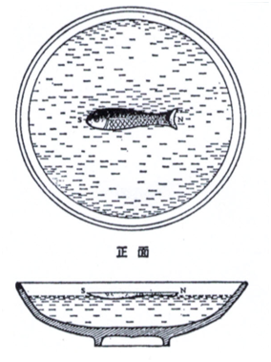
Figure 1. Chinese compass floating on water. Reconstruction according to Wang Chen-to, following Dawson/Needham (1964), p. 253.

Data

Historical Data

The authors are not historians but they need to know and use some “minimum amount” of historical data. These are about names and periods of reigns of various kings/emperors/rules, whose pyramids will be studied, both in Mesoamerica and China. We gathered data from Longhen (1998), Coe (2002), Wan Guoding (1956), Moule (1957), Needham (1964), Selešnikov (1974), Paludan (2004) or Zhang Shifeng (2006).
Olmécs are usually defined as an independent culture of Central America, more or less preceding Maya (1500 BC – 300 AD), living in tropical lowlands of Mexican gulf. Maya belong to the interval about 200 – 1200 AD, Teotihuacan culture to 0 – 900 AD, Zapotécs to 500 BC – 800 AD, El Tajín to 250 – 900 AD, and finally we speak about Aztécs (~1200 – 1521 AD, till the conflict with European invaders). China had about three hundred emperors and empresses and had seven former capital cities. The first sovereign Chinese emperor was Qin Shi Huang Di (Shihuang), born 246 BC, reign since 221 BC until his death in 210 BC. His mausoleum is northeast of Xi´an and the relevant pyramid is the largest known pyramid in the world (taking into account its horizontal, not vertical dimension).
Starting from the Qin dynasty, all data concerning Chinese emperors can be counted reliably and accurately, as far as their personal and posthumous names and/or titles are concerned. This includes the dates of their birth (year, month, day), accession to the throne (including abdication and/or deposition) and death (we started with Moule, 1957).
Relationship between the Chinese calendar and our own calendar does not add any additional error to our results (in a big contrast to extremely bad situation known for Maya, see, e.g., Klokočník et al. 2008). The Chinese calendar and its transformation to ours are precise to within a day, i.e. much more precise than we need for our purpose here (see below for more information). They were two Han dynasties: older West Han (206 BC till 9 AD) and newer East Han (about 25 – 220 AD). This was one of heydays for China and logically many pyramids belong to this period (but not only to this).
In Table 1, we have a list of emperors and empresses (these are denoted by symbol +) from West and East Han (symbol * is for the East Han). We give their dynastic (posthumous or temple) and civic (personal) names.

Table 1. The emperors from dynasties West Han and East Han.
Because of the evolution of knowledge of Chinese history, some data (for example interval of reign) can be slightly modified. This table serves only as rough information

East Han (*), empress (+).

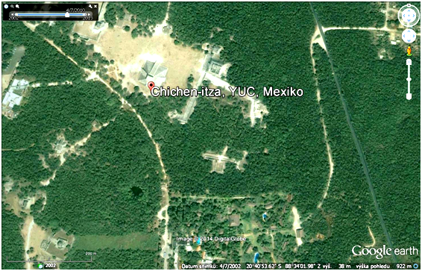
(a)
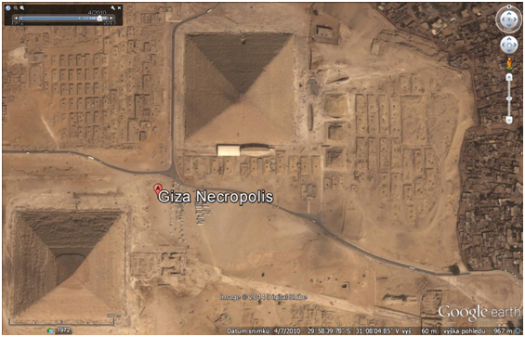
(b)
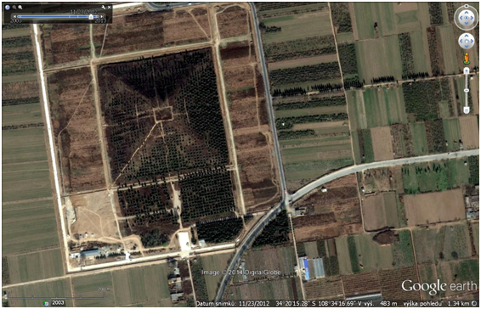
(c)
Figures 2. a,b,c. Pyramid Castillo, Chichén Itzá (Yucatán), Cheops and Chefren pyramids in Giza (Egypt) and the pyramid near Maoling mausoleum (Xi´an area). North in all images is up. Compare size: the same scale for all three figures. © Google Earth and 2014 Digital Globe.
For emperors younger than 500 AD, the name of dynasty is added to the name of the emperor. For the dynasty Tang and (North) Song (Zong), name of temple is given instead of name of emperor. For empress, they didn’t have official posthumous or temple names. Our Table 1 is not a complete listing of Chinese emperors, but it is a register needed for our later use.
Mesoamerican pyramid is made from smaller blocks of stone (mostly limestone) and often has an upper temple, steps, various statues, and inner spaces. It never stays separately, but is surrounded by various ceremonial and other important structures.
Chinese pyramid (tumulus, feng tu) is a monument, burial mound, upper part of a tomb building, now visible on the surface as a hill (often with bush/trees). It is made from packing soil (clay), which may cover the base from more resistant material (bricks, stone, bronze). Its pyramidal shape can be overlooked from the ground, because many pyramids look like natural hills covered by grass, bush or trees. But from air (airplane or from satellite images), the pyramidal shape is evident, out of any discussion (which was possible before satellite images with high resolution become available).
Thanks to Google Earth, with today’s resolution around one meter horizontally as well as vertically, we can now see many details on the pyramids and around them (each step and bush, see below). The pyramids are inseparable parts of much more extensive complexes or systems of burial sites. They are equipped by walls, triumphal arches from stone, water works, sacred paths with alleys of stone statues, etc. The underground mausoleums, often with rich equipped tombs, are nearby.
Here we compare size, shape and space orientation of the pyramids in three different localities: (1) Kukulcán (Quetzalcoatl) pyramid, known also as El Castillo, in Chichén Itzá (Yucatán, México), famous for its astronomical-solar orientation (declined from astronomical south-north direction to 24⁰ east, which enables creation of special shadowing effects at sunset in equinoxes), (2) pyramids in Giza, Egypt (astronomically oriented very precisely, probably by stars, to the astronomical north) and (3) the pyramid belonging to Maoling mausoleum, west of Xi´an (China, province Shaanxi), with deviation about 8⁰ west of astronomical north, Figures 2 a,b,c, all taken from Google Earth.
The largest Chinese pyramids are well comparable to (or larger horizontally than) the Egyptians. Thanks to material usually used for their construction, however, the Chinese pyramids normally cannot be so steep, sharp and thus also as high as the pyramids in Egypt, Sudan-Nubia, Mesoamerica, Perú, Tenerife or zikkurats in Mesopotamia.

Paleomagnetic Data

Since the lithospheric motions and the secular motion of the geographic pole (i.e. pole of rotation of the Earth’s body) are much slower and smaller on the scale of few thousand years than the fast and “erratic wobbling” of the magnetic pole of the Earth, we can for our purpose neglect the former. The magnetic pole wandering has huge amplitude, is of irregular nature, with a tendency to be periodic. Archaeological materials such as baked clay, mud, bricks, walls, baked rock, burnt walls, porcelain, ceramics, tiles, pottery, coins, etc. can be used to retrieve a record from the ancient geomagnetic field. We speak about paleomagnetic (or archaeomagnetic) pole wandering reconstruction. We show it by Figures 3 a,b (redrawn from book of McElhinny and McFadden, 2000, p. 23), for the last 4000 years.

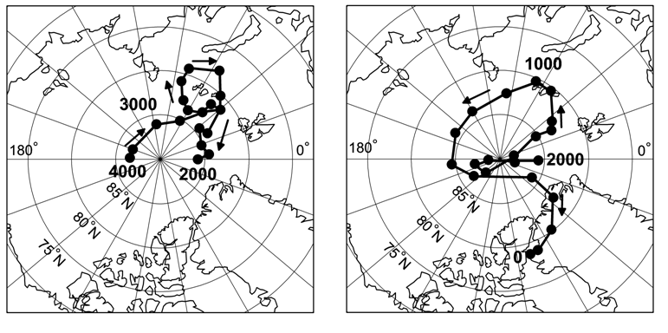
a b
Figures 3. a,b. Motion of north paleomagnetic pole related to “stable” pole of rotation of the Earth, during last 4000 years. Time counted backward from present time (dot for each 100 years). According to (McElhinny and McFadden, 2000), redrawn by © J. Kostelecký.
Now we wish to see how the magnetic pole motions affect the direction observed from place and time of in our interest when the direction is defined by a compass and not astronomically. Compass measures directions (angles, azimuths) with respect to local magnetic lines of force l_{m} (roughly saying to the current magnetic pole) and not in direction l_{a} to the astronomical north or the pole of rotation of the Earth. The horizontal (azimuth) difference l_{m} – l_{a} is paleomagnetic (archaeomagnetic) declination. The example of it for Beijing during the last few thousand years is in Figure 4a (more details below), for Mesoamerica in Figure 4b.

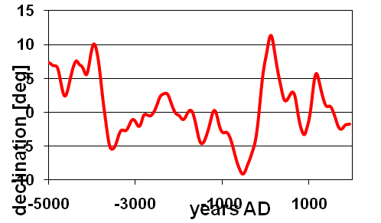
Figure 4a. The paleomagnetic declination for Beijing during the last 7000 years according to CALS7K.2 model (Korte et al. 2005). Positive declinations are east of astronomical pole (positive values on the curve), negative have west deviations (negative values).
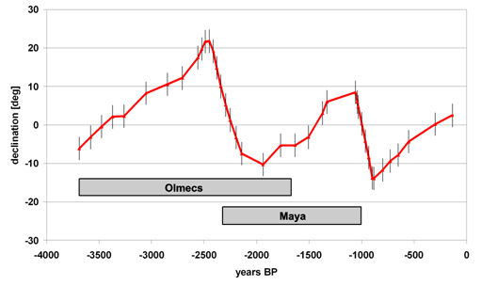
Figure 4b. The paleomagnetic declination for México during last 4000 years from measurements in Mesoamerica, as provided by Boehnel (priv. commun., 2006), with standard deviations. Details in Klokočník et al. (2007) and Charvátová et al. (2011).
Paleomagnetic declination is derived from indirect (proxy) data mentioned above over the world and can be a part of a global solution in spherical harmonic expansions. Since time of Fuson and Carlson, there is a big progress in knowledge of paleomagnetic declinations, but still they have a low accuracy, hardly better than 3⁰, usually 5⁰ (Korte, private commun. 2011–2013). Recent models for the declinations are available from Korte et al. 2005; Donadini et al. 2007; Korhonen et al. 2008, Korte & Constable 2008, Donadini el al. 2009, or Korte et al. 2011. Thanks to a friendly relationship with Monika Korte (Germany) we received paleomagnetic declinations for required localities and time intervals from her recent paleomagnetic field models (example in Figure 4a). Similarly from Harald Boehnel (México) from measurements in México (example in Figure 4b).
Recall that the Fuson hypothesis (Fuson, 1969) says that a building (wall, object) oriented using a compass at the time of its construction or at its last reconstruction bears the information about the direction towards the magnetic pole at that time. Thus, we can, at least theoretically, correlate the date of the building (re)construction with its orientation. The practical problem is still low accuracy of the paleomagnetic data (declination inclusive), which is not greater than a few degrees.

Measurements by a Compass

We developed easy and efficient methods of measuring and computing astronomical azimuths by means of a compass (Klokočník et al. 2007, Charvátová et al. 2011, Pavelka et al. 2013). It is generic (software available on request). The final precision of this procedure is dictated dominantly by the inaccuracy of paleomagnetic data now available.
We make use of a precise and large “mining” compass with reading to 1 degree (Figure 5). When walls are very irregular, we have to repeat measurements several times to reach such formal precision. The compass reads the magnetic azimuths. To change them to the astronomical azimuths, we need to know current magnetic (not paleomagnetic!) declination on the spot at the given time of measurements. It is available from a model (NOAA, Satellite and Information Service, NGDC (National Ocean & Atmosph. Admin., National Geophysical Data Center), www.ngdc.noaa.gov, item “declination calculator”). But also (and preferably) can be measured and computed on the spot.
We measured azimuths by a compass, we selected a baseline (as long as possible in the given terrain conditions) and we measured – by handy GPS – coordinates at the end points of the baseline. These are used to compute astronomical azimuth of the baseline. We compare it with the magnetic azimuth measured by the compass and the difference between those two quantities is the magnetic declination. Its value is used to correct all magnetic azimuths measured at that locality and time. Precision is between 1 and 2 degrees, which is sufficient to our purpose.
When measurements in situ are not possible (for example, the entry on the pyramid is forbidden), we have to rely upon airplane or satellite images of the objects of our interest, which logically leads us to © Google Earth.

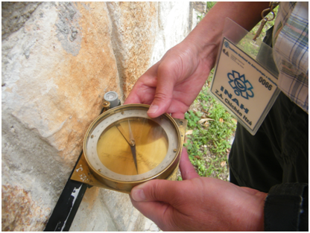
Figure 5. Our compass with fitting about 40 cm long for easy and fast field measurements. Reading with precision 1⁰. Photo © D. Lampířová, 2010.

Help by Google Earth

Google Earth is a valuable source of satellite and airplane images, now in many areas of the world with high resolution of about 1 meter in horizontal as well as vertical direction. Its installation is easy and free of charge: http://www.google.cz/intl/cs/earth. Satellite images from older satellite Landsat had resolution tens of meters, now technology with new satellites Ikonos, QuickBird, OrbView or GeoEye achieves better than a meter level, which however cannot be used in some countries because of limitations posed by a local law. New satellite images usually have one black & white band with high resolution and 4-8 bands in visible and infrared light with a lower resolution. By the method known as pansharpenning, the black & white image is colored; it results in (false) color images with maximum geometric resolution.
Together with figures from Google Earth, we always provide coordinates of the center of the scene or top of the pyramid; these are geodetic latitude φ and longitude λ, as written on the particular scene with Google Earth. They are in common (worldwide) geocentric WGS 84 coordinate system. The reader can easily verify the existence of the individual object discussed here by using these coordinates to make his/her own virtual flight around the pyramids by Google Earth.
Figure 6 shows the locality Maoling on the image where the border line between the low and high resolution zones of Google Earth at that time (~2008) was just east of the pyramid and went south-north – compare to Figures 2c or 7a with already high resolution.

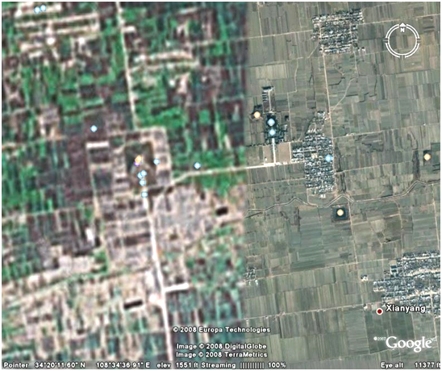
Figure 6. Locality Maoling (φ = 34⁰ 20´ 18´´, λ = 108⁰ 34´11´´) on image where the border line between the low and high resolution was just east of the pyramid – compare to Figures 2c or 7a. © Google Earth and 2008 Europe Technologies, Digital Globe and TerraMetrics. Now the whole scene has the high resolution (see Figures 2c and 7a).
Figures 7a,b show the northeast side of the same pyramid on a slant view arranged by Google Earth tools. By this way, we demonstrate maximum resolution achievable and available via Google Earth today. We can see individual bushes or steps (at other pyramids) on a pyramid. The same is true nowadays for the whole area of Xi´an and many places in Mesoamerica but certainly not yet for the whole territory of these countries.

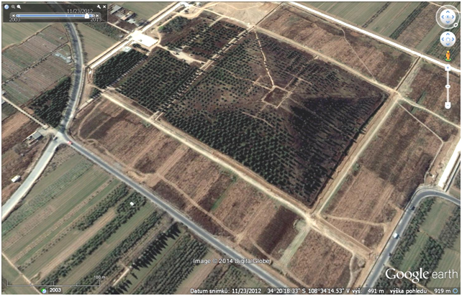
a
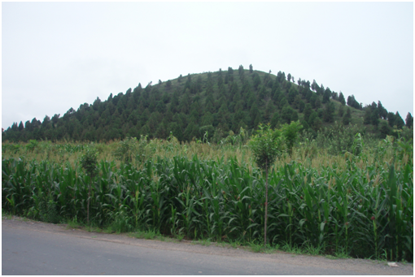
b
Figures 7 a, b. The pyramid at Maoling on a slant view via © Google Earth and Digital Globe (2014), compared the ground photo, to demonstrate capability of satellite images today. Ground photo © J. Klokočník, 2011.

Chinese Pyramids in Our Analysis

Figure 8 shows the main pyramids around Xi´an (they are usually in groups, clusters). The town center is labeled by rectangle. “Qin” means place of terracotta army and pyramid of Qin Shi Huang Di nearby, both near the town of Lintong, east of Xi’an. The symbol “A” is for a civic airport. In the next, we show photos (satellite images and ground photos) of a few interesting pyramids from this area. The paper would be extremely long to contain figures of all pyramids analyzed by us. We gather up information to Table 2.
Mausoleum Maoling (Mao Ling, Mao is local name and ling means mausoleum) belongs to the emperor Wu(di) (Han Wudi), 5th of dynasty West Han [born *157 BC as Liu Che, reign 140 (or 141) – 87 BC (†, when he died)]. The pyramid´s top has these coordinates: φ = 34⁰ 20´ 18´´, λ = 108⁰ 34´ 11´´ (Figs. 2c, 6, 7, 9 a,b). The ground/floor plan is approximately a rectangle with sides about 240 m long (it is longer than side of Cheops pyramid in Giza). Today´s height is ~ 45 m.
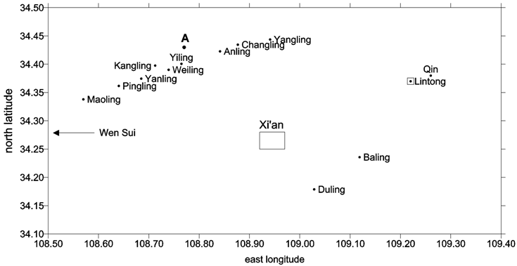
Figure 8. Map of pyramidal localities around town of Xi´an. (A is the airport). Drawn by © J. Kostelecký.
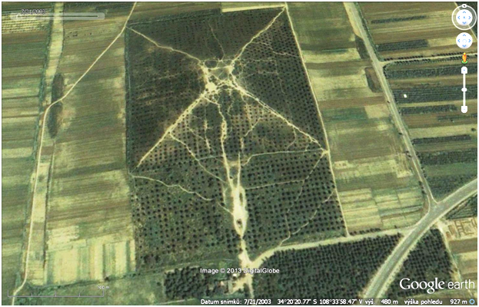
a
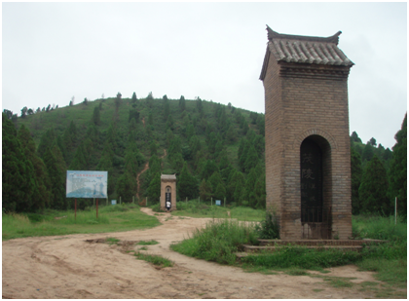
b
Figures 9. a,b. Pyramid at Maoling locality. © Google Earth, historical snapshot from 2003, when it was still possible to climb to the top. Ground photo on former sacred path, taken from south, © J. Klokočník, 2011.
By Google Earth, we can see evident deviation of the pyramid (and surrounding fields and other nearby objects) west of the cardinal direction 8-8.5⁰ (see the vertical views in Figures 2c and 6). East of the pyramid, there is a large mausoleum, Maoling, with gardens and pavilions and a small pyramid of Huo Qubing (Huo Chűping), nephew of Wudi. Southeast from this place, there is a series of smaller pyramids with the same orientation and mausolea/pyramids known as Pingling and Yanling.
The largest pyramid in Figure 10a (Yanling) belongs to the emperor Cheng(di), not far from the pyramid of his father Yuan(di). Cheng(di) (*51 BC), born as Liu Ao, reign 32(33) – 7 BC. Note a chain of smaller pyramids (of his relatives) with identical orientation (west deflection) and snow on the northern sides of pyramids (satellite photo here is from February). Figures 11 a, b show locality Kangling; the pyramid belongs to emperor Ping(di), again from the dynasty West Han (reign 1 BC – 5 AD).

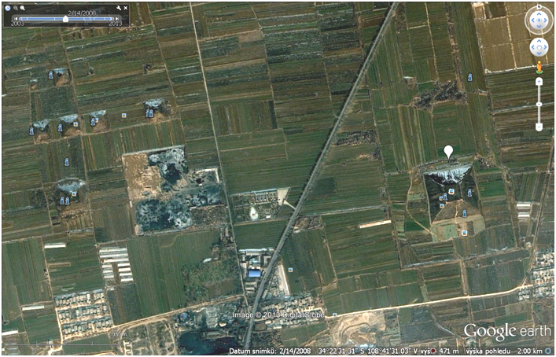
a
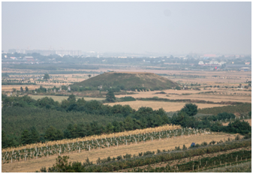
b
Figures 10. a, b. Yanling, West Han, emperor Cheng(di). (a) winter snapshot with snow (see white symbol) on northern side of the largest and other pyramids and also in some of field ditches. Coordinates of the top: φ = 34⁰ 22´ 30´´, λ = 108⁰ 41´ 53´´. © Google Earth. (b) Ground photo, © Yue Xu, 2013.
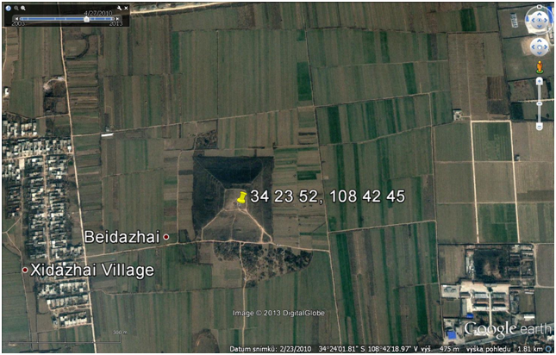
a
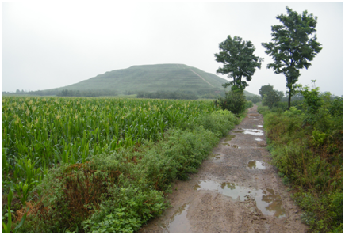
b
Figures 11 a, b. Kangling, West Han, emperor Ping(di). φ = 34⁰ 23´ 52´´, λ = 108⁰ 42´ 45´´. © Google Earth. Ground photo from its west side; © J. Klokočník, 2011.
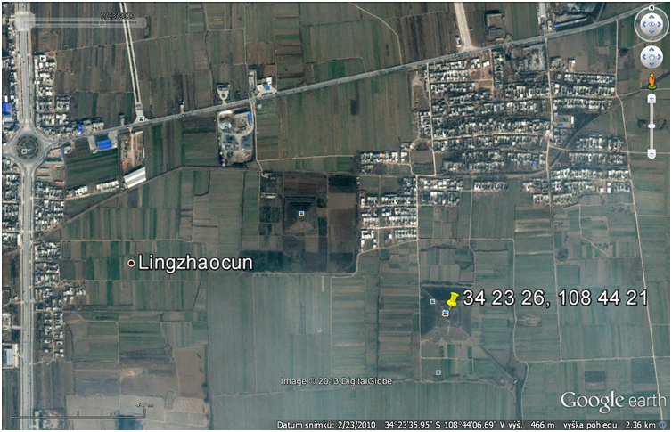
a
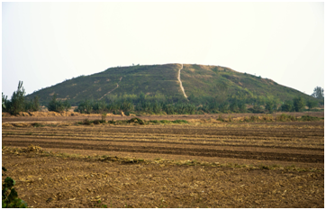
b
Figures 12 a, b. Weiling, West Han, emperor Yuang(di) (yellow pin), φ = 34⁰ 23´ 26, λ = 108⁰ 44´ 21´´. Size about 160 m, large top platform. Pyramid on left belongs to one of his wives. © Google Earth. Ground photo © Yue Xu, 2013.
Figures 12 a, b show Weiling; on left (yellow pin) is pyramid of Yuang(di) (*75 BC, reign 48– 33 BC), West Han. The pyramid on right hand side is probably of one of his wives (object is called Han Xiao Yuan Huang Hou Ling).

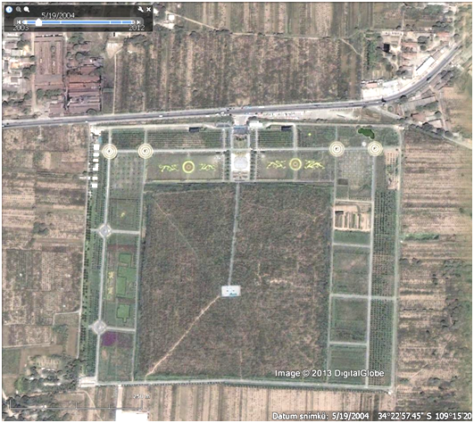
a
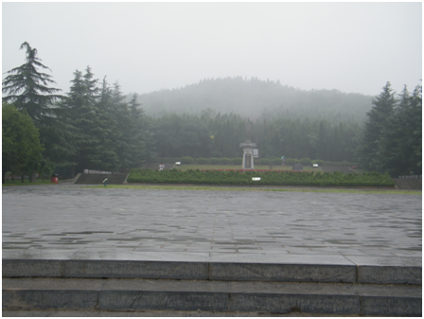
b
Figures 13 a, b. Pyramid of the first Chinese emperor Qin Shihuang. φ = 34⁰ 22´ 53´´, λ = 109⁰ 15´ 14´´, © Google Earth. Pyramid intentionally looks like a natural hill with trees. Ground photo from northern side (when raining) by © J. Klokočník, 2011.
Figures 13 a,b show the huge Qin Shi Huang Ling, already mentioned above. Figures 14 a,b show one of three pyramids in Duling (south-east of Xi´an); the emperor Xuan(di), *91 BC, reign 74(73)–49 BC. Two pyramids nearby are of his first and third wives, Xu and Wang. The orientation of all these objects in a cluster is again the same.
Baling is East of Xi´an and has three pyramids. They belong to emperor Wen(di), 202 BC, reign 180 (179) – 157 BC. Two nearby pyramids are devoted to his wife (Dou) and mother (Bo Tai Hou Nan Ling, φ = 34⁰ 13´ 16´´, λ = 109⁰ 05´ 48´´; φ = 34⁰ 14´ 09´´, λ = 109⁰ 07´ 07´´).

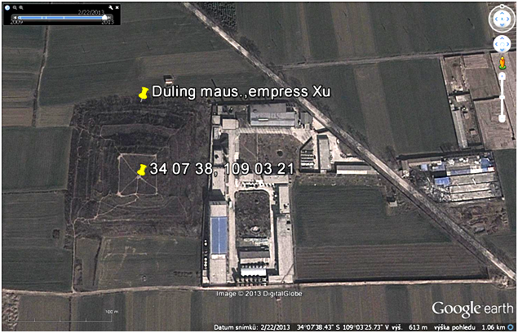
a
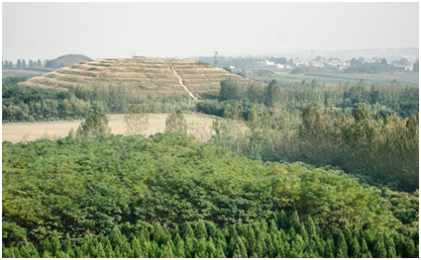
b
Figures 14 a, b. Duling. Pyramids of emperor Xuan(di) and his wifes, here of the empress Xu, φ = 34⁰ 07´ 38´´, λ = 109⁰ 03´ 21´´. © Google Earth. Right: Ground photo © Yue Xu 2013, Wang Huang Hou Ling from pyramid of Hanxuandi.
They have very strange orientation (Figures 15 a,b): east departure from north 22-24⁰. This exceptionally cannot be explained nor as a solar orientation (does not fit for this latitude for solstices) nor as orientation by compass (is too much declined).
Similar orientation (east deviation 16-17⁰) was found for Nanliang Hutai in Xining (province Qinghai), about 100 km west of Xi´an. It comes from dynasty Dong Jing, 316 – 420 AD. According to Liu and Wu (2012), it was not a tomb but a platform for army parades. This means that this object is excluded from our further investigation (maybe the same is true for Baling).
Object called Tailing, situated about 85 km west of Xi´an, in town Yangling (province Shaanxi), is a tomb of emperor Sui Wen(di) (*541 AD, reign 581– 604 AD). The dynasty Sui (Suej) is dated to 581– 618 AD. The orientation of the pyramid is south-north.
From East Han dynasty, we found and included into our analysis the pyramid of emperor Guang Wu(di) (*5 BC, reign 25–57 AD). The capital of China was moved from Xi´an to Luoyang (province Henan). Pyramid’s orientation is 0–5⁰ east (φ = 34⁰ 50´ 36´´, λ = 112⁰ 35´ 21´´). From the dynasty Tang, we have object Gongling of emperor Yizong (reign 656 – 675 AD), located near town Goushi (province Henan), φ = 34⁰37´59´´, λ = 112⁰ 48´ 40´´. We work also with five smaller objects at Luoyang, dynasty (North and South) Song (960 –1279 AD). All have eastern deviations from the cardinal direction (3 to 5⁰).
Many objects are not of classical pyramidal shape; e.g., the mausoleum Qianling (φ = 34⁰ 34´, λ = 108⁰ 13´), of emperor Gaozong (Kao-Tsung), from dynasty Tang, reign 649(650) – 683, is round. We also do not include the following objects due to various reasons: (i) the mausolea and circular tombs in autonomous area Ningxia Hui, near town Xingqing(fu), known as Western Xia tombs or under name royal tombs Xixia (at φ = 38⁰ 26´, λ = 105⁰ 59´ and around), dynasty West Xia (Tangut), period 1032(1038) – 1227 AD; (ii) small pyramids in Inner Mongolia, 1 km north of town Sijazi (province Aohan), because Google Earth has no resolution high enough; (iii) stone pyramidal objects known as Xituanshan cultural ruins site; (iv) the step pyramid Zangkunchong in Ziban (originally Korean territory), probably from period (Koguryo, Goguryeo, Koryo) before 500 AD; (v) the ”Tomb of General” (Jiangjun Fen), Goguryeo kingdom (37 BC – 668 AD), at town Ji´an (province Jilin, φ = 41⁰ 09,5´, λ = 126⁰ 13,5´).

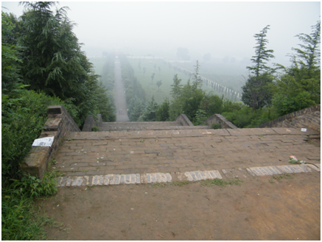
a
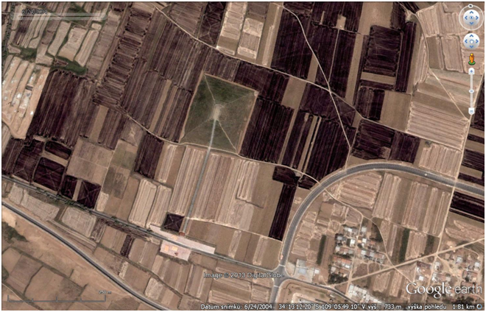
b
Figures 15 a,b. Baling pyramids east of Xi’an with strange orientation, east departure from astronomical north 22-24⁰. Here is Bo Tai Hou Nan Ling, pyramid of mother of emperor Hanwendi. Historical satellite image from 2004 (still without recent ground structures), © Google Earth. Ground photo from the top of the object with steps and sacred path: © J. Klokočník, 2011.
Possibly many other interesting and important structures are missing in our study and should be studied later (the first author continues research with Chinese colleague Fenni Kang). Hain (2011) in his book in chapters 10–12 wrote about various further pyramids, but because of a low resolution of Google Earth in the relevant areas (e.g., Qianling, see above, at φ = 34⁰ 34´ 29´´, λ = 108⁰ 12´ 53´´), we cannot verify his findings.

Orientation of Chinese Pyramids

Facts

Table 2 summarizes our data to test the Fuson hypothesis (Fuson 1969, Carlson 1975) and Figure 16 depicts the results. This analysis is a continuation and improvement of Charvátová et al (2011). In Table 2, we first give geodetic coordinates (latitude and longitude) of the top of the pyramid that belongs to the respective (nearby) temple (tomb, mausoleum).
The data are from Google Earth. If more than one pyramid exists in the given locality (they are often groups of pyramids sharing the same orientation), then the coordinates relate to the main (usually the largest) pyramid (usually pyramid of the emperor). The coordinates are given with precision to the arc second, which corresponds to 20–30 meters on the ground. Then name of the temple (or locality) is given, name of the dynasty, posthumous or temple name of the emperor (empress has the symbol +); some civil names were already presented in table 1. Next is the interval of the reign, since enthronement till his/her death or abdication. This part was laborious and we had to use several information sources (sometimes they differ and then we prefer newer literature or Chinese sources).
Charvátová et al (2011) has been in turn corrected and amended, namely with the help of information from Paludan (2004), Hain (2011) and by local Chinese sources (e.g., works of the Xianyang Inst. of Archaelogy, 2010, Liu Chuncheng, 2012 etc, Kang, priv. commun. 2011–2014). For example, the oldest pyramid, labelled #1 in Charvátová et al. (2011), identified with the emperor Kangwang (dynasty West Zhou, 1020–996 BC), belongs – according to the new investigation (Xianyang Inst. of Archaelogy, 2010) – to wife of Yuandi (dynasty West Han, ~50 BC). It is logical; both pyramids are in the same place and create a “group” which should be indicated by their close age and identical orientation (Figure 12a). Also, in this vicinity, no pyramid older than West Han dynasty is located. Other mistakes in Charvátová et al. (2011) occurred because we had to rely upon Google Earth or Internet at that time, where wrong identification of some of the pyramids had appeared. It was discovered by W. Hain (Hain, 2011; priv. commun. 2013) when reading our paper Charvátová et al. (2011), and thus, removed by us. These corrections are the result of “detective investigation” of Fenni Kang in original Chinese literature.
The last column of our Table 2 contains information about the space orientation of the pyramids (their south-north sides) with respect to the astronomical north (deviations to west or east of north, in degrees).
These values were read by a tool built inside Google Earth (see: tools, ruler, course) and/or by measuring azimuths on prints of images reproduced from Google Earth, by using software AutoCAD, independent on Google. It provides results much more precise than achievable by Google Earth itself, in arc minutes, much more than we need for our purpose (but it requires special software and time for measuring). In many cases in Mesoamerica and few cases in China, the orientation was measured also on the spot by our compass (during visit of J. Klokočník in Xi’an area, 2011) and processed as described above.

Interpretation and Discussion

The orientation of the pyramids reveals west as well as east deviations from the astronomical north; sometimes it is “exactly” (within ±1⁰) south-north (SN, then zero is in Table 2). A small statistics follows in which we consider twins or groups of the pyramids “emperor – his wife or concubine” or “emperor – his relatives”, having the same orientation, to be “one object”. In total 34 objects were tested according to Hain (2011), but in our Table 2, it is just 21 lines. The west deviation has about 60% of the pyramids, with prevailing value 8⁰ (35% from the total); the exact SN (±1⁰) orientation has 25% objects. East deviation shows the remaining 15%. The values of paleomagnetic declination, necessary to compare the “observed” (measured) values in Table 2 (the last column) with a model or “prediction”, were kindly provided by Monika Korte (GFZ Potsdam). As a reference datum to compare the age and the orientation, the second year of the respective reign interval was taken. A comparison of the measured declinations with declinations from a paleomagnetic model is in Figure 16. Plotted are the curve of paleomagnetic declinations (with error ±5⁰) and the measured orientation of the pyramids – the dots with numbers corresponding to numbers in Table 2.
We can see (Table 2) that (i) during the West Han dynasty (roughly 200 BC–0 AD) the declination was negative (west deviation from the astronomical azimuth), and it was decreasing sharply with time until positive values appeared later on. (ii) The change was huge and statistically significant even when we count the paleomagnetic declinations ±5⁰ with uncertainty. From the largest negative to the largest positive value of the declination, the change was about 20⁰ during 400 years or about 15⁰ during 200 years.
Figure 16 convinces us that there is a fair agreement between the paleomagnetic data (the curve and standard deviation) and the observations (dots) showing the orientation and age of the pyramids. The trend during 200 BC and 0 AD is the same for the curve and for the dots. For the newer objects, mostly from the Luoyang area (on right side of Figure 16) we can see good agreement between the two. All this supports the Fuson hypothesis, but of course does not mean any proof of it.

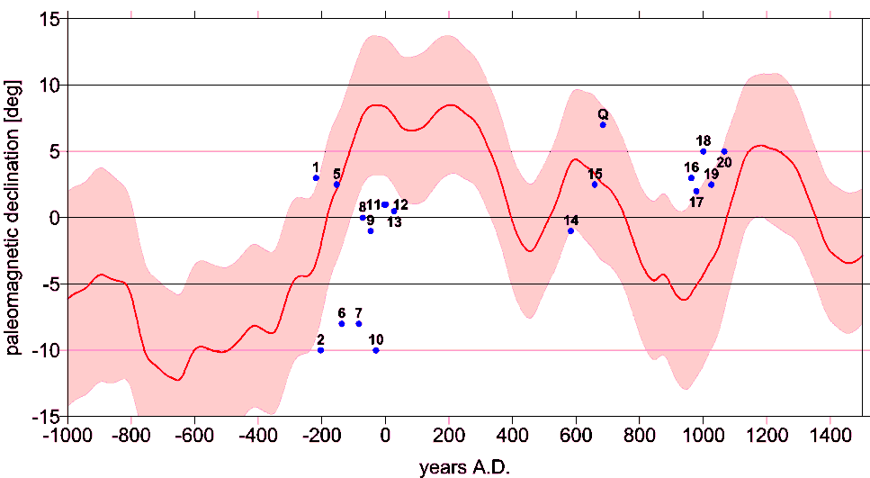
Figure 16. Comparison of the paleomagnetic declinations (d in degrees), computed from the newest model of Korte (the curve with the standard deviation ±5⁰, with the age and declinations gathered in Table 2 (blue dots). Drawn by © Jan Kostelecký.

Table 2. List of temples with their geodetic coordinates, names of temples (or localities), dynasties, posthumous names of emperors, periods of their reign and “orientation” (angle in degrees west (negative) or east (positive) of astronomical north, as measured on the spot or derived from satellite images in Google Earth). Under one item, a whole group of pyramids can be hidden (see the text).

 | geographic coordinates |  | name of mausoleum (locality) or of group of pyramids with the identical orientation | dynasty, emperor/empress (+)  (posthumous name/temple name) | period of reign | Orientation
# | latitude ⁰ ´ ´´ | longitude⁰ ´ ´´ |  |  |  | Degrees
1 | 34 22 53 | 109 15 14 | Shihuangling | Qin, Shihuangdi | 221-210 BC | 3 E
2 | 34 26 05 | 108 52 36 | Changling | W. Han, Gaozu (di) | 206-195 | 10 W
3 | 34 25 22 | 108 50 29 | Anling | W. Han, Huidi | 195-188 | 16 W
4 | 34 14 09 | 109 07 07 | Baling | W. Han, Wendi | 180-157 | 22-24 E
5 | 34 26 38 | 108 56 27 | Yangling | W. Han, Jingdi | 156-141 | 2-3 W
6 | 34 20 18 | 108 34 11 | Maoling | W. Han, Wudi | 140-87 | 8 W
7 | 34 21 48 | 108 37 51 | Pingling | W. Han, Zhaodi | 86-74 | 8 W
8 | 34 10 44 | 109 01 42 | Duling | W. Han, Xuandi | 74-49 | 0
9 | 34 23 25 | 108 44 21 | Weiling | W. Han, Yuandi | 49-33 | 1 W
10 | 34 22 30 | 108 41 53 | Yanling | W. Han, Chengdi | 32-7 | 10 W
11 | 34 24 03 | 108 45 53 | Yiling | W. Han, Aidi | 6-1 BC | 1 E
12 | 34 23 52 | 108 42 45 | Kangling | W. Han, Pingdi | 1 BC - 5 AD | 1 E
13 | 34 50 36 | 112 35 21 | Guangwudiling | E. Han, Guangwudi | 25-57 AD | 0-5 E
14 | 34 17 19 | 108 01 22 | Tailing | Sui, Wendi | 581-604 | 1 W
15 | 34 37 59 | 112 48 40 | Gongling | Tang, Yizong | 656-675 | 0-5 W
Q | 34 34 07 | 108 12 58 | Qianling, sacred path | Tang, Gaozong and Wuzetian+ | 649-705 | 7 E
16 | 34 39 55 | 112 57 16 | Yongchangling | Song, Taizu | 960-976 | 3 E
17 | 34 40 27 | 112 56 42 | Yongxiling | Song, Taizong | 976-997 | 2 E
18 | 34 42 17 | 112 58 28 | Yongdingling | Song, Zhenzong | 998-1022 | 5 E
19 | 34 44 40 | 112 58 48 | Yongzhaoling | Song, Renzong | 1023-1063 | 2-3 E
20 | 34 44 47 | 112 58 22 | Yonghouling | Song, Yingzong | 1064-1067 | 5 E
21 | 36 37 58 | 101 44 46 | Nanliang Hutai Altar | Dongjin* | 317-402 | 16-17 E
⁺ empress, * platform for army parades, 4, Q, 21 … objects with special orientation (see the text). © Jaroslav Klokočník and Fenni Kang, 2014. This table is a continuation of table 1 in (Charvátová et al. 2011), © Springer and GFÚ AV ČR, Praha. The object Q has no pyramidal shape, so that the orientation concerns its sacred path.

A deeper insight however shows unpleasant discrepancies. The trend visible in Figure 16 is clear but some details are not. For example, objects 7 and 10 do not agree with the paleomagnetic curve too much. Moreover, we have not plotted objects #4 and #21 from Table 2, because their east deviations (22–24⁰ or 16–17⁰, respectively) are out of scale of Figure 16. But we know (from the previous chapter) that #21 was not a pyramid, but a platform for army parades. Its orientation was obviously dictated by pragmatic reasons. The question is whether also #4 can be such case.
Based on these results, should we support or refuse the Fuson hypothesis? Does there exist another, for example, astronomical explanation of orientation of the pyramids? In Perú and Mesoamerica, there one often meets astronomical, solar, summer/winter solstice orientation (with respect to azimuths of sunrise or sunset at those important days), or with respect to the Moon, Venus or other celestial bodies rise or set. Is anything like that possible in China?
Theoretically, yes. The formula for the astronomical azimuth of sunrise/sunset, e.g. from Klokočník and Kostelecký (2013) or Pavelka et al (2013), applied for Xi´an and Luoyang, yields approximately 29⁰ south or north of east or west for sunrise or sunset at the solstices. But no object from Table 2 fits to it. Besides the solstices, we can test equinoxes (see the small statistics above) or calendric orientation; it means astronomical orientation at a specific – for that society at that time – important date (birthday of emperor, day of victory of our emperor over enemy, etc.). To test calendric hypothesis we would need to know the data of birthdays with one day precision, and it is not yet feasible. It would be totally different task than this present analysis.
There is another important factor concerning the orientation of the pyramids, specifically in China, which must be accounted for. It was feng-shui, a method and practice learning how to do the proper orientation of important buildings to lead cosmic energy. It accounts for effects of mountains and rivers, too. By the majority of emperors, it was also believed that the exact direction to east (or south) is available exclusively for god, never for human beings. Nobody, including the emperor, had permission to use this specific direction. So, after the appropriate direction/azimuth was determined by means of a compass (of course being affected by the magnetic declination not known at that time!), the emperor or feng-shui expert had to decide the definitive orientation of the pyramid to deviate slightly from the forbidden direction. What does it means? It is a complication for our research. We can reconstruct paleomagnetic orientation, but we will hardly be able to decode decisions of each individual emperor. But maybe it is also a solution to the problem: the paleomagnetic declinations and orientation of the pyramids was changing with time, it is reconstructed; the trend in Figure 16 is correct, it is clear. But, moreover, there is another influence to the final orientation; it is the need for the direction of the individual pyramid to differ from the “sacred” direction reserved for god only.

Conclusion

The Fuson hypothesis explains that pyramids and other important buildings in Mesoamerica were oriented by a lodestone compass, i.e. not with respect to the astronomical north. The direction to the magnetic pole is changing with time relatively rapidly. If a pyramid is oriented by a compass, then its age and orientation should correlate. To test the hypothesis, we need to reconstruct behavior of paleomagnetic declination for a given place and time. Our research, including our own measurements in situ supported this hypothesis for Mesoamerica (Klokočník et al. 2007). Recently, we have extended our investigation to China (Charvátová et al. 2011), and here we summarize our newest results which amend previous ones.

- In China, as in many other countries over the world, pyramids exist. Pyramidal shape of the majority of the burial mounds is evident from satellite and airplane images (Google Earth). It sounds self-evident that we speak about the pyramids but it was not so obvious in the past because in the past Chinese authorities refused the existence of pyramids for a long time and free entry to the area with them was strictly forbidden for foreigners.
- Covers (the upper part) of Chinese pyramids were made mostly from packing soil (clay). Inside, the tomb and mausoleum is from better, durable materials.
- Horizontal (but not vertical) size of Chinese pyramids is well comparable with that of pyramids in other countries.

There are about 100 pyramids around Xi´an (province Shaanxi). The pyramid of the first Chinese emperor Qin Shihuang (di) has a roughly rectangular ground floor plan with sides about 350 m long (in a contrast to about 220 m for Egyptian Cheops pyramid). The Qin’s pyramid is thus the largest known pyramid in the world (horizontally).

- The pyramids are inseparable parts of much larger complexes (tombs, pavilions, walls, gardens, sacred paths, statues, water equipment, etc.) built for life after death of important persons (like emperors and people around them).
- Selection of a place for these objects and their orientation with respect to south (east) is not arbitrary but is dictated by strict rules (feng-shui).
- The pyramids usually appear in groups; the largest is for the emperor, others for his wife(s), concubine(s), relatives, and persons important for the state.
- The fact that pyramids in a group (cluster) belong together (their unity and appurtenance) is expressed by their joint orientation with respect to the cardinal south-north direction, which is the same for all pyramids in the given cluster and is dictated by orientation of the main pyramid in the group. Also, roads and fields bear this orientation (and it must be so for a very long time), up to some distance from the central pyramid, where the “effective zone” of another central pyramid from another group can be detected. Feng-shui and pyramids thus contribute to special design of Chinese landscape.
- To perform feng-shui, a magnetic compass is needed. It is known in China probably since time immemorial, minimum since the West Han dynasty (~200 BC).
- “Orientation by a compass” means that a wall/rim of an object is oriented by means of an instrument called compass; it is not thus directed to the astronomical pole (pole of Earth’s rotation), but with respect to the local magnetic lines of force. The magnetic field is changing significantly and quickly (erratically) in comparison with the gravity field parameters, and in turn, the orientation by a compass depends on time.
- Paleomagnetic declinations are clue to test of the Fuson hypothesis. Their knowledge is based on various proxy data. For Mesoamerica we were provided directly by paleomagnetic declinations from measurements (Boehnel), while for China we have to rely upon spherical harmonic models for paleomagnetic quantities (Korte et al) which yield inevitably smoothed results. Precision of today’s paleomagnetic declinations for Mesoamerica or China is between 3⁰ and 5⁰ and is the main error source in our investigations.
- Based on the paleomagnetic declinations, valid for Xi´an (and its wide surrounding), and based on historical data on reigns of Chinese emperors (mostly from the dynasty West Han), we tested the Fuson hypothesis (originally formulated for Mesoamerica). Our data in Table 2 and results in Figure 16 fairly support the Fuson hypothesis.
- The final, definitive decision on the orientation of a pyramid before its construction was on the relevant emperor. The direction exactly to south (east) was forbidden even for him (being reserved for god). By this way, we explain why the trend shown in Figure 16 (for the curve and the dots) is OK, while the individual values sometimes differ.

Chinese pyramids should be perceived as an inseparable part of worldwide phenomenon of building objects of pyramidal shape and as a part of worldwide cultural heritage. Successively, they are being discovered for the whole world. They require and deserve relevant care, because they are a part of amazing Chinese history.

Acknowledgments

We thank Ms. Fenni Kang, PDr, Prof. RNDr. Josef Kolmaš, DrSc, Ing. Ivanka Charvátová, CSc, Monika Korte PDr, Walter Hain, Francis and James Chens, Ms. Wu Gong and Mr. Yue Xu for their kind help during our research in various aspects.

References

Aveni, A.F. (2001). Skywatchers of Ancient Mexico, Univ. of Texas Press, Austin.
Carlson, J. B. (1975). Lodestone Compass: Chinese or Olmec Primacy?, Science, 189, 753-760.
Coe, M.D. (2002). The Maya. Thanes & Hudson, ISBN-0-500-28066-5.
Charvátová, I., Klokočník, J., Kostelecký, J. & Kolmaš J. (2011). Chinese Tombs Oriented by a Compass: Evidence from Paleomagnetic Changes versus the Age of Tombs. Studia Geophys. et Geodet., 55, 159-174.
Donadini, F., Korte, M. & Constable C.G. (2009). Geomagnetic Field for 0-3 ka: 1. New Data Sets for Global Modelling. Geochem. Geophys. Geosyst., 10, Q06007, doi: 10.1029/2008GC002295.
Flanners, K.V. & Marcus, J. (2005). Excavations at San José Mogote 1, Memoirs of Museum of Anthropology, Univ. Michigan, ISBN-978-0915703593.
Fuson, R. H. (1969). The Orientation of Mayan Ceremonial Centers. Annals Assoc. American Geogr., 59, 494-511.
Hain, W. (2011). Pyramiden in China: Neue archäologische Entdeckungen im Reich der Mitte. Publ. House Fachverlag für Traditionelle Chinesische Meduzin, Stralsund Anfang, ISBN-978-3-941814-27-1.
Klokočník, J., Kostelecký, J. & Vítek, F. (2007). Pyramids and Ceremonial Centers in Mesoamerica: Were They Oriented using a Magnetic Compass? Studia Geophys. et Geodet., 51, 515-533.
Klokočník, J., Kostelecký, J., Böhm, V., Böhm, B., Vondrák, J. & Vítek, F. (2008). Correlation between the Mayan Calendar and Ours: Astronomy helps to answer why the most popular correlation (GMT) is wrong. Astronomische Nachrichten, 329, 426-436, ISSN-0004-6337, doi: 10.1002/asna.200710892.
Klokočník, J., Kostelecký, J. & Pavelka, K. (2011). Google Earth, inspiration, and instrument for the study of ancient civilizations. XIII Intern. CIPA Symp., Publ. Geomatics 6, Czech TU FCE, 193-211.
Kolektiv Xianyang institute of archaeology (2010). Xi Han, Di Ling, Zuan Yan, Diao Cha, Bao Gao. Archaeological Report No. 5 of Xianyang Institute of Archaeology, sect. 8.2., 2010.
Korhonen, K., Donadini, F., Riisager, P. & Pesonen L. J. (2008). GEOMAGIA50: an Archeointensity Database with PHP and MySQL. Geochem. Geophys. Geosyst., 9, Q04029, doi: 10.1029/2007GC001, 893.
Korte, M. & Constable, C. G. (2008). Spatial and temporal resolution of millennial scale geomagnetic field model. Adv. Space Res., 41, 57-69, doi: 10.1016/j.asr.2007.03.094.
Korte, M., Genevey, A., Constable, C. G., Frank, U. (2005). Schnepp E.: Continuous Geomagnetic Field Models for the Past 7 millenia. Geochem. Geophys. Geosyst., 6, Q02H15, doi: 10.10.1029/2004GC000800.
Korte, M., Constable, C., Donadini, F. & Holme, R. (2011). Reconstructing the Holocene geomagnetic field. Earth and Planet. Sci. Letts., 312, 497-505, doi: 10.1016/j.epsl.2011.10031.
Kuo Shen (1088). The Dream Pool Essays (Meng Xi Bi Tan). Transl. to modern Chinese by Hu Dao Jing and Jin Liang Nian, China Intern. Radio Press, ISBN-9787507833218.
Liu Chuncheng, Wu Yumin (2012). Xi ning Hu Tai De Li Shi Ren Lei Xue Kao Bian. The Jour. of Qinghai Normal Univ. (Phil. and Social Sci. Edition), 34, 51-58, doi: 1000-5102-(2012)02-0051-07.
Lin Wenzhao (1985). The social factors in the invention of the compass in China. Jour. of Dialectics of Nature, No. 5.
Liu Yifeng, Liu Yiwei, Liu Bingzheng (2010). The Research of Compass Si Nan. Jour. of Dialectics of Nature, No. 5.
Longhen, M. (1998). Ancient Mexico, White Star S.r.l., Vercelli, Italy; Czech transl. publ. by Rebo production, s.r.o., Prague.
Moule, A. C. (1957). The Rules of China, Routledge & Kegan, London.
Needham, N. J. (1962). Science and Civilisation in China, Vol. 4. Physics and Physical Technology. Part I, Physics, Cambridge Univ. Press, Cambridge, ISBN 7-03-011232-6/0.1738.
Needham, N. J. (1964). The Legacy of China, (R. Dawson Ed.), Oxford at the Clarendon Press.
Pan Dong. (2009). The Mechanisms of Chinese Tumuli. Grand Garden of Science, No. 1.
Paludan, A. (2004). Chronicle of the Chinese Emperors, the Reign-by Reign Record of the Rules of Imperial China. Thames & Hudson Ltd, London, ISBN 0-500-05090-2.
Pavelka, K., Klokočník J. & Kostelecký, J. (2013). Astronomicko-historické otazníky Mezoameriky a Peru, (Astronomical-historical quieries of Mesoamerica and Perú), Publ. House Czech TU Prague, 287 pp. (in Czech).
Slavíček, K. (1995) Listy z Číny do vlasti a jiná korespondence s evropskými hvězdáři (1716-1735), [Lettres from China to homeland and other correspondence with European astronomers (1716-1735)], ed. J. Kolmaš, Publ. House Vyšehrad, s.r.o., Prague, ISBN 80-7021-127-X, 269 pp. (in Czech).
Wan Guoding. (1956). Zhongguo Lishi Jinianbiao (Chronological Tables of Chinese History), 1956, Comm. Press, Beijing.
Wang Zhenduo. (1948). Campass as Si Nan, Zhi Nan Zhen and Luo Jing Pan in China. Chinese Acta Archaeologica Sinica, No. 3.
Zeng Yongfeng. (2008). The Brief Analysis of Hutai in Ximing, Qinghai Social Science, 1, 187-188.
Zhang Shifeng. (2006). Emperors' Mausoleums in the East of Central Shaanxi Plain, Journal of Weinan Teachers University, 21, #4.

LCH

∗ (+420) 323 620 158. E-mail address and web: jklokocn@asu.cas.cz, www.asu.cas.cz/~jklokocn.
# kost@fsv.cvut.cz

